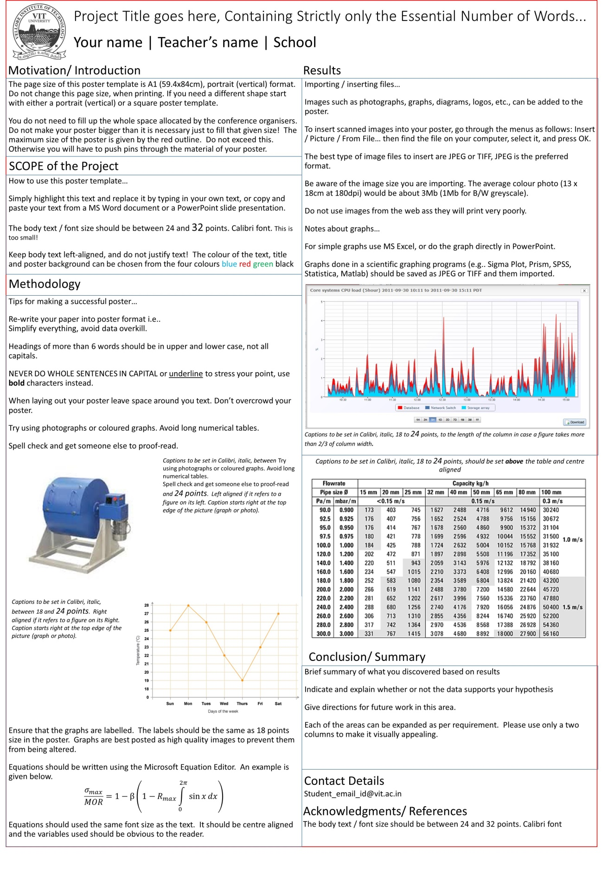

Php.net , www.w3schools.com>php>php_sessions

**Benefits of ThoughtXchange**

Interaction will be easier.

User posts can be viewed by others.

Less time consuming.

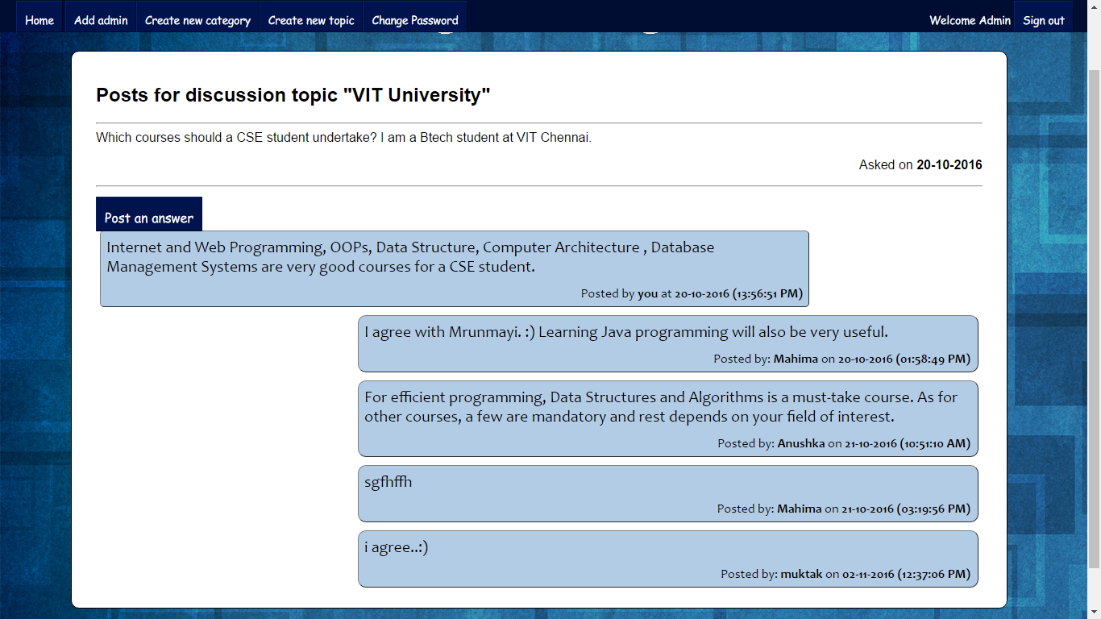

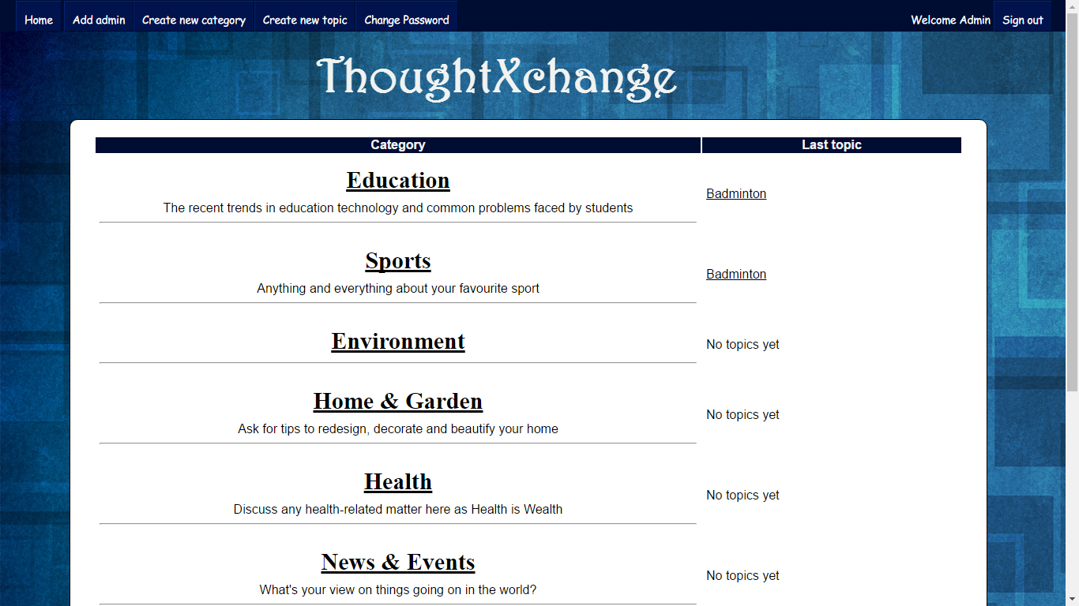

[anushka.bohara@vit.ac.in](mailto:anushka.bohara@vit.ac.in)

CONTEXT DIAGRAM

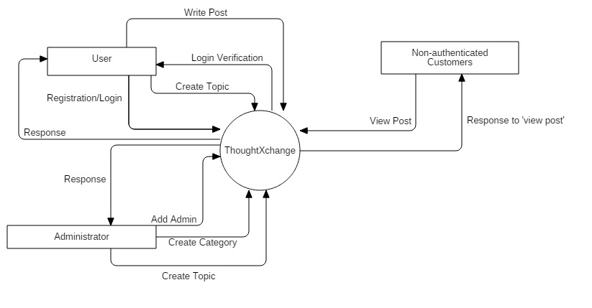

USE CASE DIAGRAM

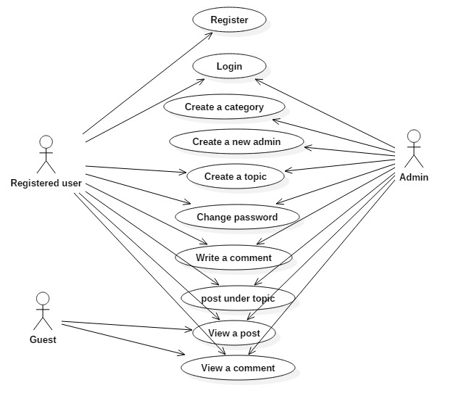

**Modules**

**1.Login/Registration:**

Registered users and administrators can login while non-authenticated users have to sign up first.

**2.Add Admin:**

An existing admin can make registered users admin.

**3.Create Category:**

Only admin can create a new category.

**4.Create Topic:**

New topic can be created by both an admin or users.

**5.Write a Post:**

Users can write the posts in the given categories

**6.Write a comment:**

The replies to the posts by users or administrators can be done.

**7.Sign Out:**

Signed in users and admin can log out from forum.

**8.Change Password:**

Registered users can login and change their password.

**9.Forgot Password:**

An OTP is sent to the registered email ID of the particular user.

The main objective of this project is to provide the users some services like clearing the doubts online by posting question & answers on this site. The different users registered into the site can reply for the questions posted by other users and thus forming discussion in addition to posting questions. The non-registered users can view the questions & answers posted into the site. Three user: admin,user,guest.

It is very important to communicate and share your knowledge and thoughts in various fields in order to grow and develop. Therefore, we decided to develop a discussion forum which would enable people to interact with people from different areas of interest and background.

**Discussion Forum: ThoughtXchange**

**15BCE1075,15BCE1167,15BCE1372|Dr. Malathi.G|SCSE**